**Abstract:**

This tool combines a REXX Exec: “**IOCDS 2 XLS.REX**”, which runs under the OOREXX interpreter on Windows, and a VBA, which is a script in the spreadsheet: “**IOCDS VBA2.xls**” to convert an IOCDS deck (in plain text) into an Excel spreadsheet.

**Author:**

Andrew Jan

**Requirements:**

A REXX environment on a Windows should be in place to run this tool. The open source: OOREXX (<http://www.oorexx.org/download.html>) is the best choice.

Also a MicroSoft Excel is needed. When the office version is upgraded, some changes must be made in the following REXX Exec: “**IOCDS 2 XLS.REX**”

The REXX Exec: “**IOCDS 2 XLS.REX**”

A VBA script: ”**IOCDS VBA2.xls**”

**z10.txt** (for the IOCDS of the 2097)

**z114.txt** (for the IOCDS of the z114U04)

**z114Z05.txt** (for the IOCDS of the z114Z05)

**z890.txt** (for the IOCDS of the 2086)

**Explanation of the Purpose:**

For easier reading of an IOCDS, the purpose of this tool is to list the IOCDS statements in an organized way in a spreadsheet format. Currently it is particularly designed to be used for the mainframe environment at ***IBM Beitou Data Center***. With appropriate modifications, however, the same tool or the concept should also possibly be suitable for the use of converting IOCDS text files from any other mainframe infrastructures.

**How to run?**

1. 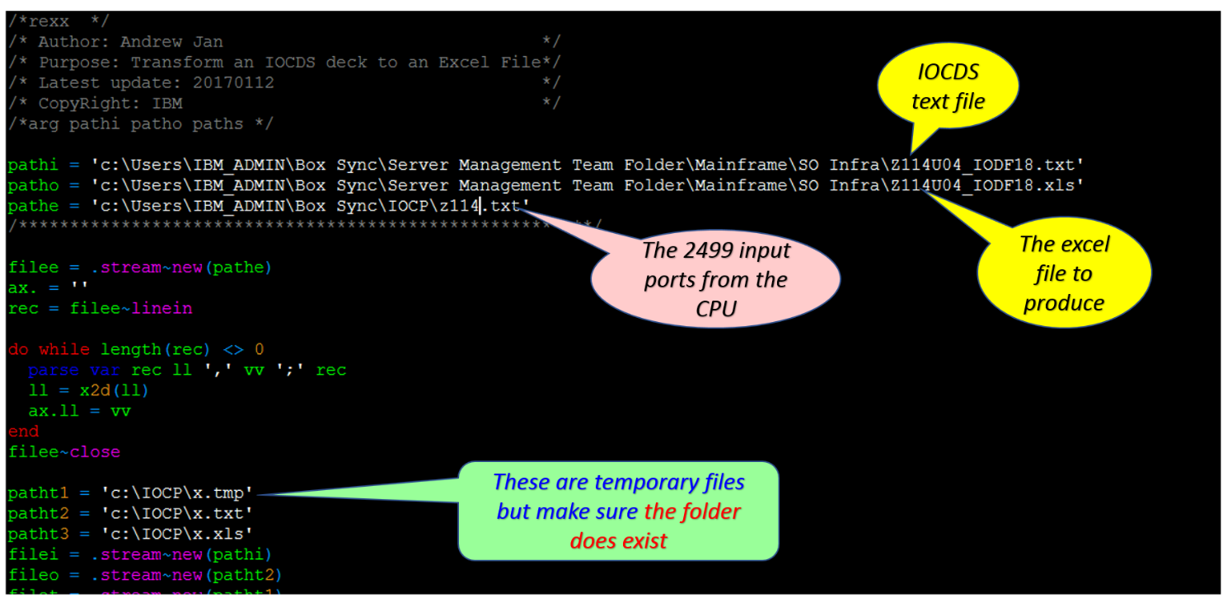Update the folder and file names in “**IOCDS 2 XLS.REX**”:
2. Execute “**IOCDS 2 XLS.REX**”. the VBA in “**IOCDS VBA2.xls**” will be automatically invoked
3. Choose “YES” when “**IOCDS VBA2.xls**” pops up the window (see the picture below)

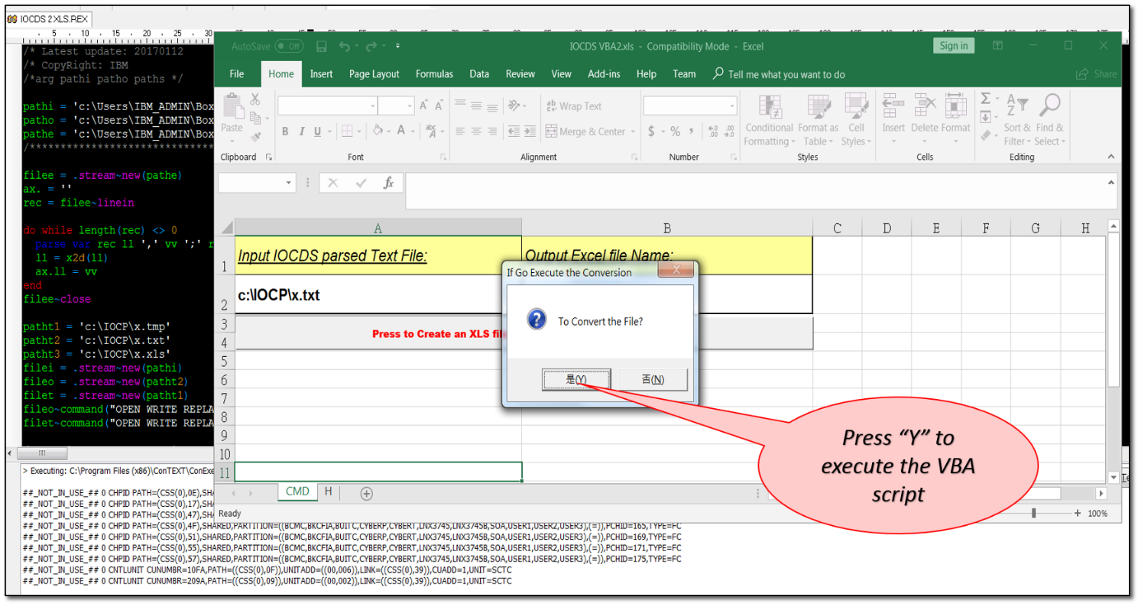

**z10.txt, z114.txt, z114Z05.txt and z890.txt**

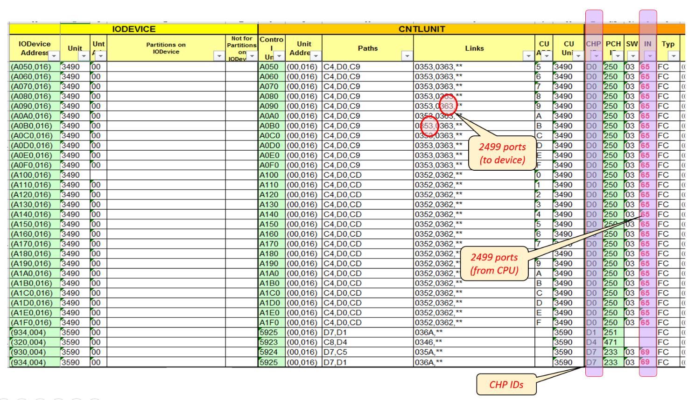These files: z10.txt, z114.txt, z114Z05.txt and z890.txt are used to provide the mainframe CPU boxes’ IO channels’ CHP numbers and the corresponding 2499 switch’s IO port numbers that these channels directly connect to.

z10.txt is for the 2097, z114.txt for z114U04, z114Z05.txt for z114Z05 and z890.txt for the 2086. These pieces of information are NOT found in an IOCDS file, but they are as critical as the definitions in an IOCDS deck.

Please see the figure above on the column marked as “**IN**”. Numbers found in this column are collected from these files.

**Maintenance:**

The following extract from “**IOCDS 2 XLS.REX**” shows how the VBA script: ”**IOCDS VBA2.xls**” is invoked. Any folder or file name or the Office version changes will need an update here.

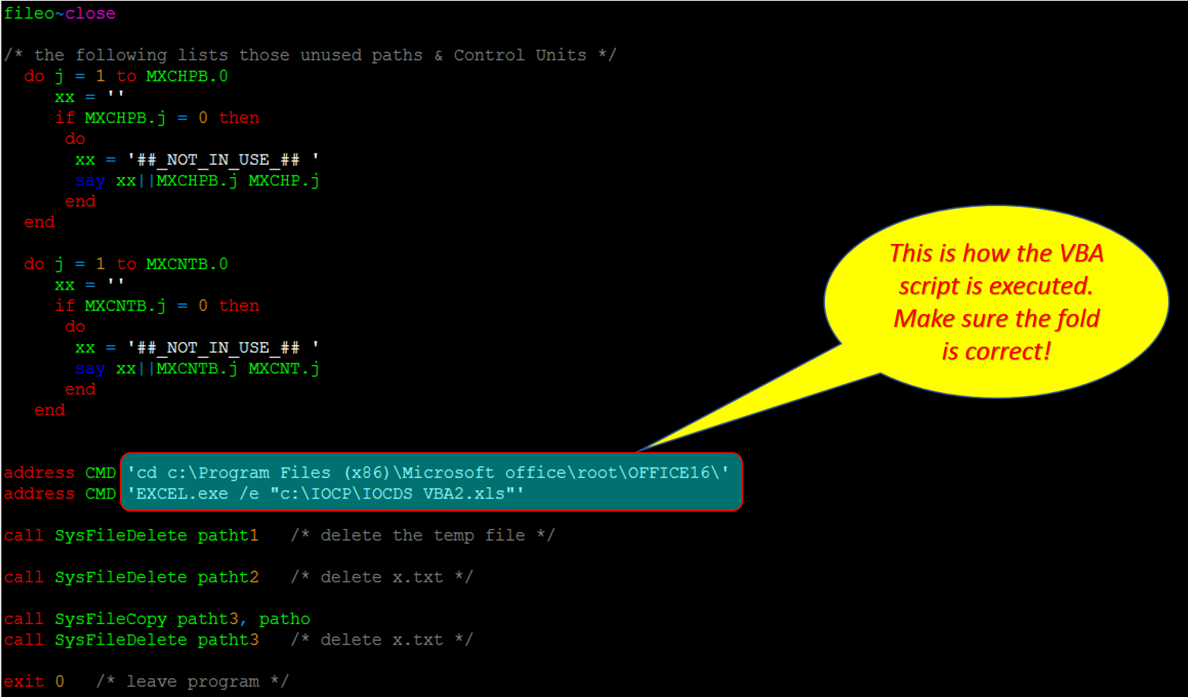

If we have to change the processing logic --- use different colors for different devices for example --- in “**IOCDS VBA2.xls**”, just open “**IOCDS VBA2.xls”** and choose ‘**NO**’ at the Popup of “**To Convert the File?**”. See the following picture.

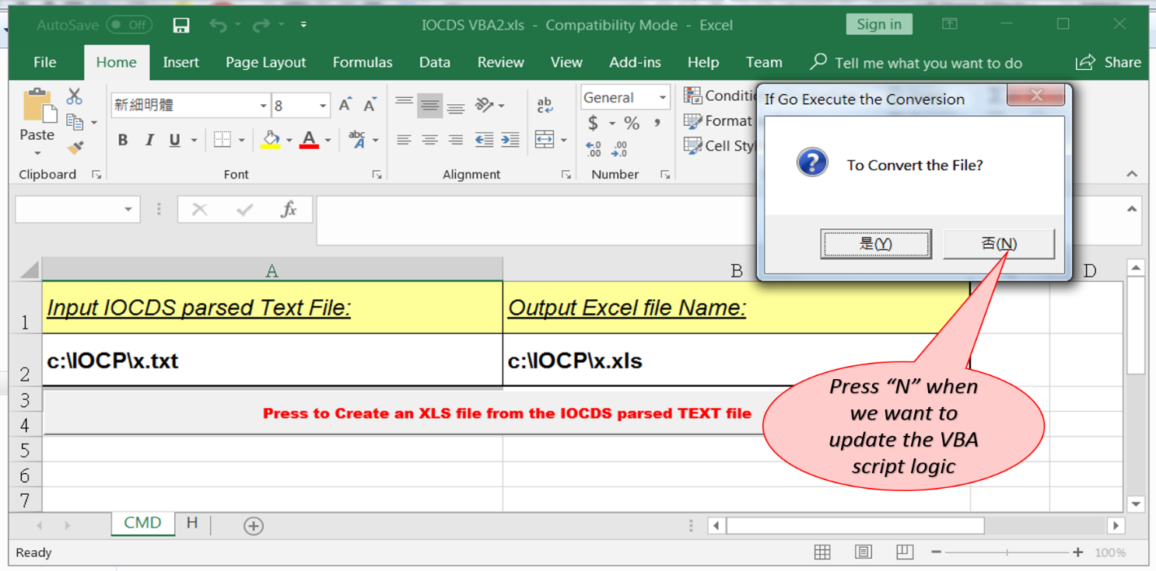

Please also note that “**IOCDS VBA2.xls**” also contain a sheet named “H” where a line of 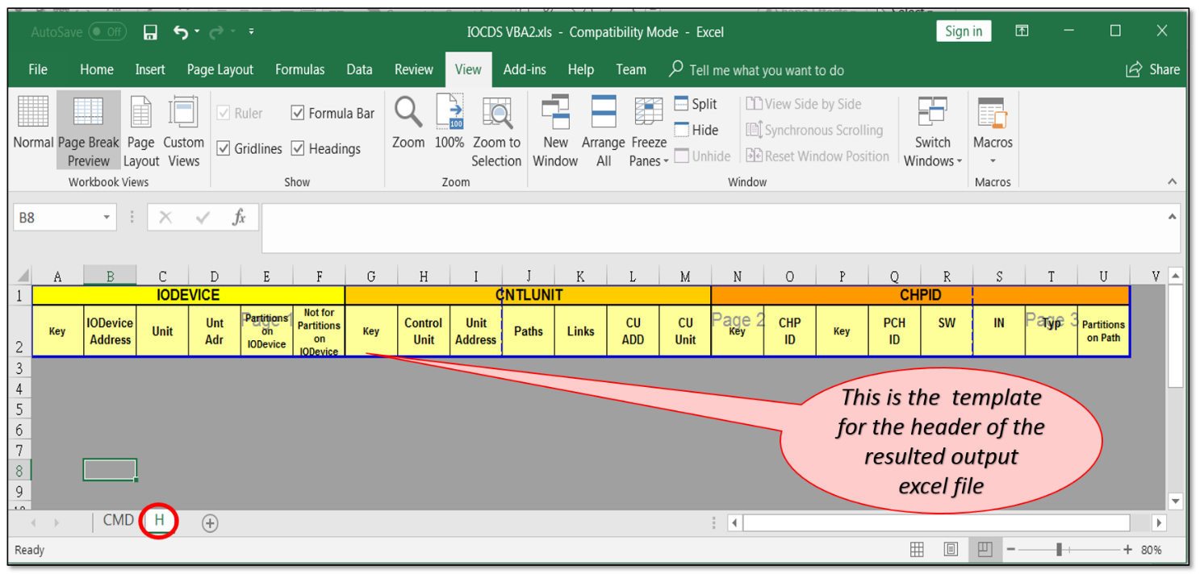header for all resulted output files resides.

**Importance:**

